Nama : Wisnu Kusumo Jati

NIM :1809081

Kelas : 5B

**PRAKTIKUM 5**

1. Source Code

Autoload.php => application / config

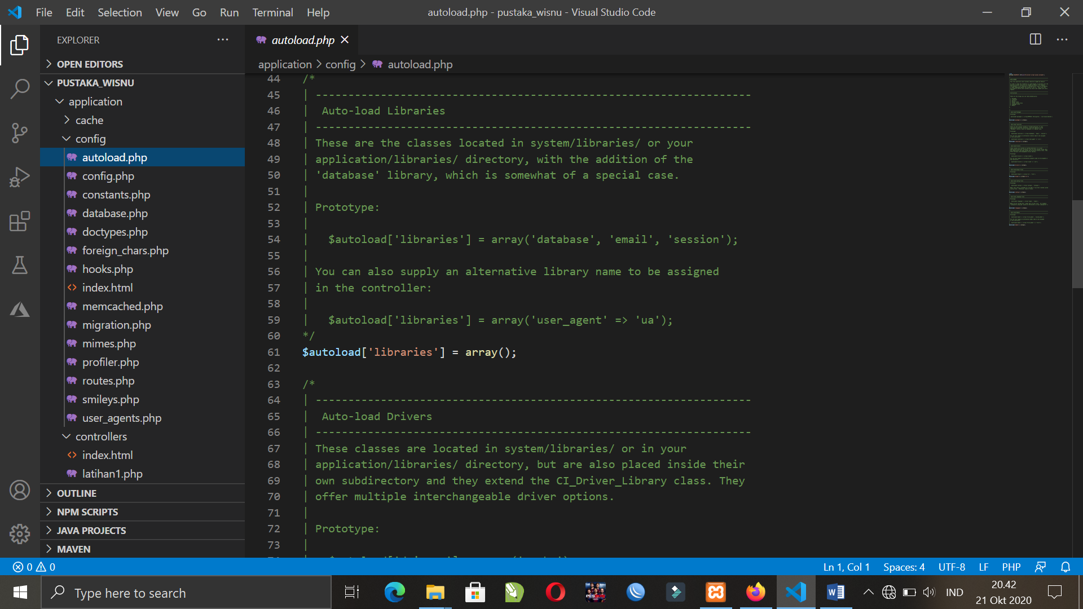

MatakuliahValidation.php => application / controller

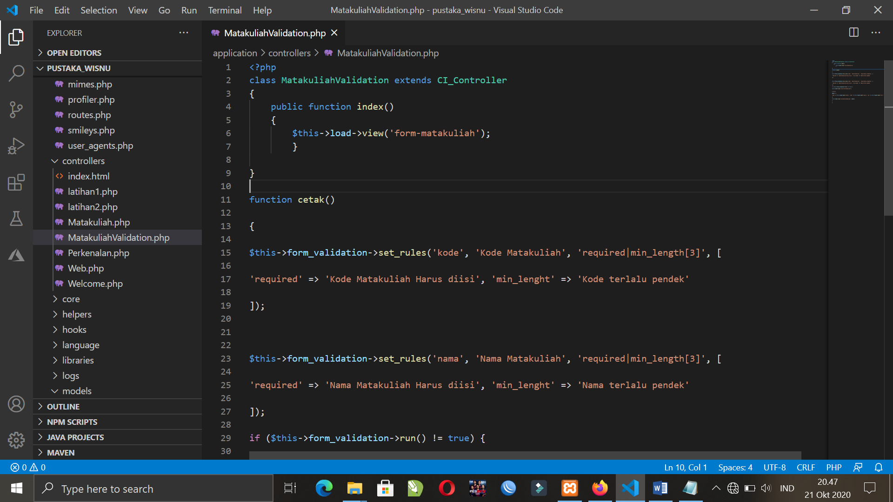

form-matakuliah.php => application / views

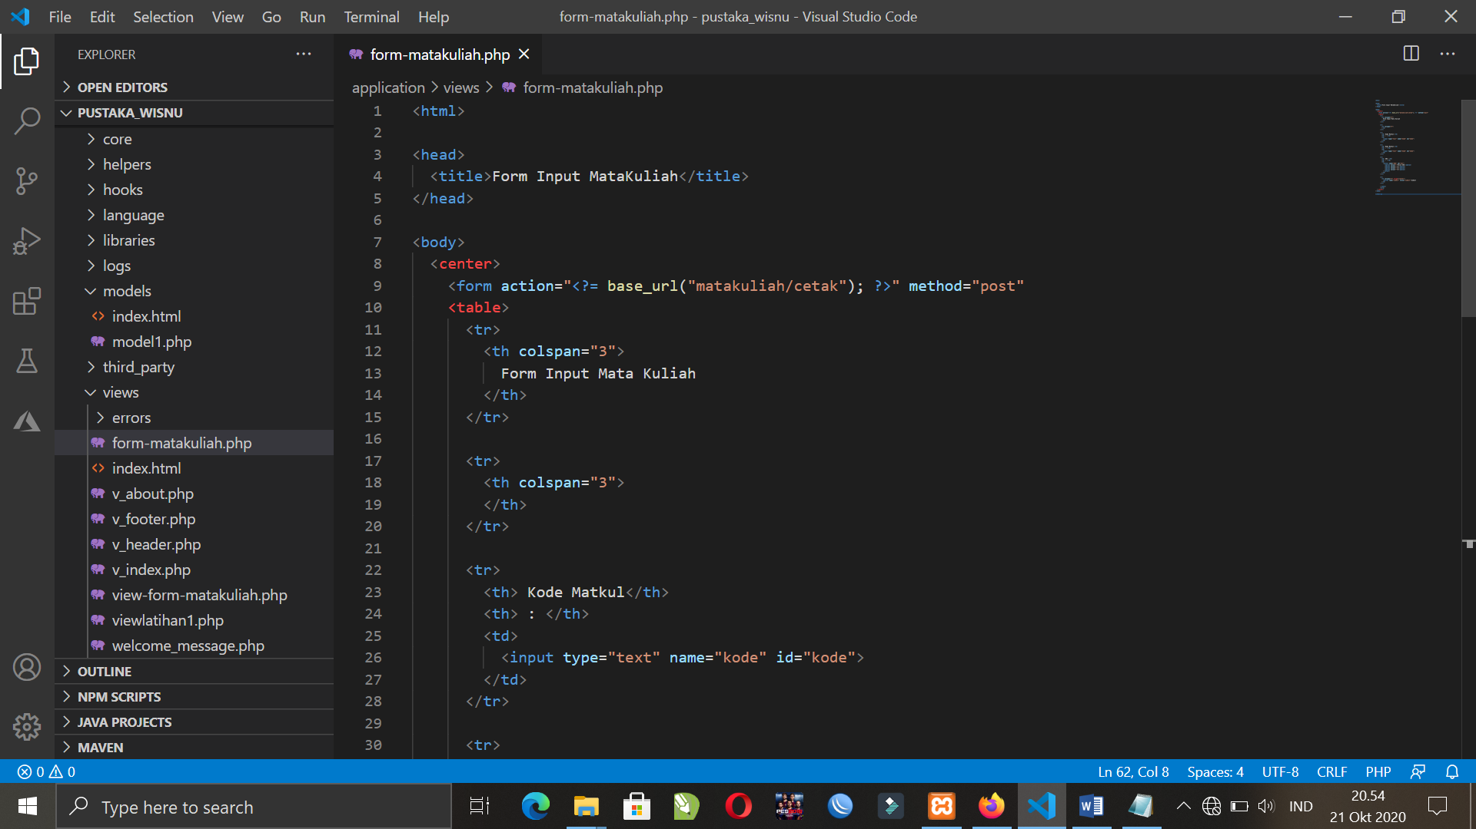

1. URL

<http://localhost/pustaka_wisnu/index.php/MatakuliahValidation>

1. Capture Hasil

